Project Proposal  
  
*Intento*

*A Project Management Solution*

Prepared By

*Afsana Chowdhury - 1731163642*

*Mst. Ayesha Siddika- 1712935642*

*CSE311L.10*

*Summer 2020*

# Table of Contents

**Table of Contents** **1**

**Proposal** **2**

**Introduction** **3**

Overview 3

Development Stack 3

**Features** **4**

**User Interface** **5**

**Database Schema** **8**

**Relational Database** **9**

**Project Timeline** **10**

**Future Plans** **10**

# Proposal

Ill-managed projects can very quickly turn into capricious monsters backstabbing at each step. With the days of manually managing projects long gone, many organizations turn to online solutions. Even if there are plenty of online solutions to manage projects, very few of them can actually optimize the workflow. Our intention is to build Intento, a web-based project management application, to help users manage their intended tasks or projects. This service will be useful for both personal projects and large scale projects consisting of several teams. That is, this application has the potential of being used as a simple online TODO application as well as a large scale corporation project management system. The greatest competitors we may find for this project are Trello and Microsoft TODO. Our solution will differ in ease of usage and the statistics shown in the profile page which will allow the user to quickly go to the projects that have close deadlines.

We hope that you will like our idea and allow us to start working on this project.

# Introduction

## **Overview**

Intento is a web-based project management application. By using this application users will be able to create and manage their projects. Users will be able to create different “projects” where they will set their goals and update the percentage they have completed. Users can also “Favorite” a project that will be shown on top of their profiles. Users can also create “teams”. The user who creates the team will be the team leader. A leader can add or remove other users. Teams can have multiple projects, and at least two users. Additionally, a team can be assigned to a project by the leader. A project can have multiple users and teams. The “Projects” will have “Intents” which can contain zero to multiple “Tasks”.

## **Development Stack**

HTML, CSS: Frontend

PHP: Backend

SQL: Database

# Features

1. **Registration system:** Users will be required to register to the service and log in to access the website.
2. **Team Management:** Users will be able to create different teams with other users of this system. Multiple teams can be assigned to each project. The team leader will have control over the members of the team.
3. **Organizing Tasks:** Tasks are the main focus of this project. Tasks can be assigned to any members existing in any team of the group. Tasks can be organized under structures called intent. A project can have multiple intents.

# 

# User Interface

The user interface may look different in the final project. However, the functionalities will be similar.

/login

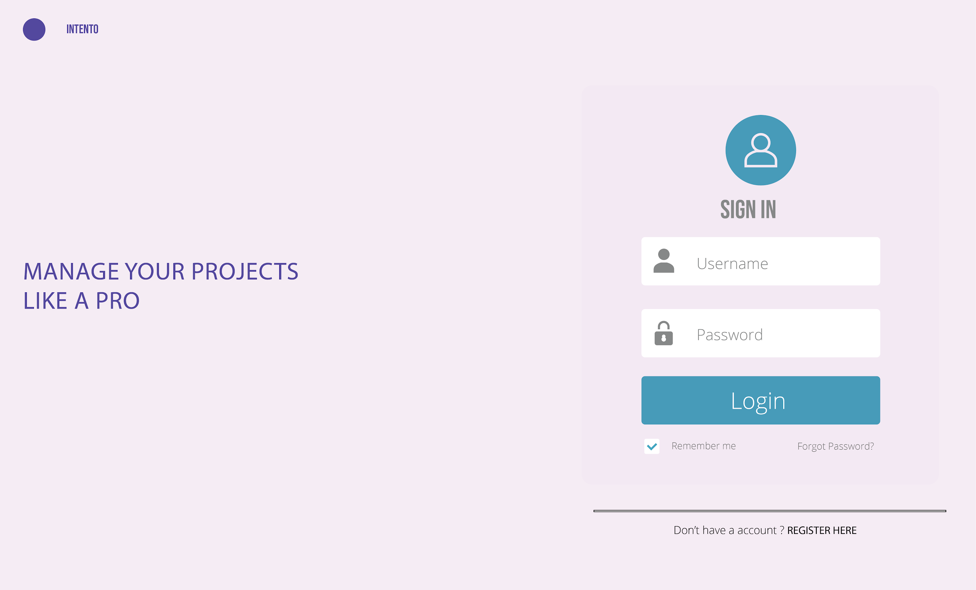

/registration

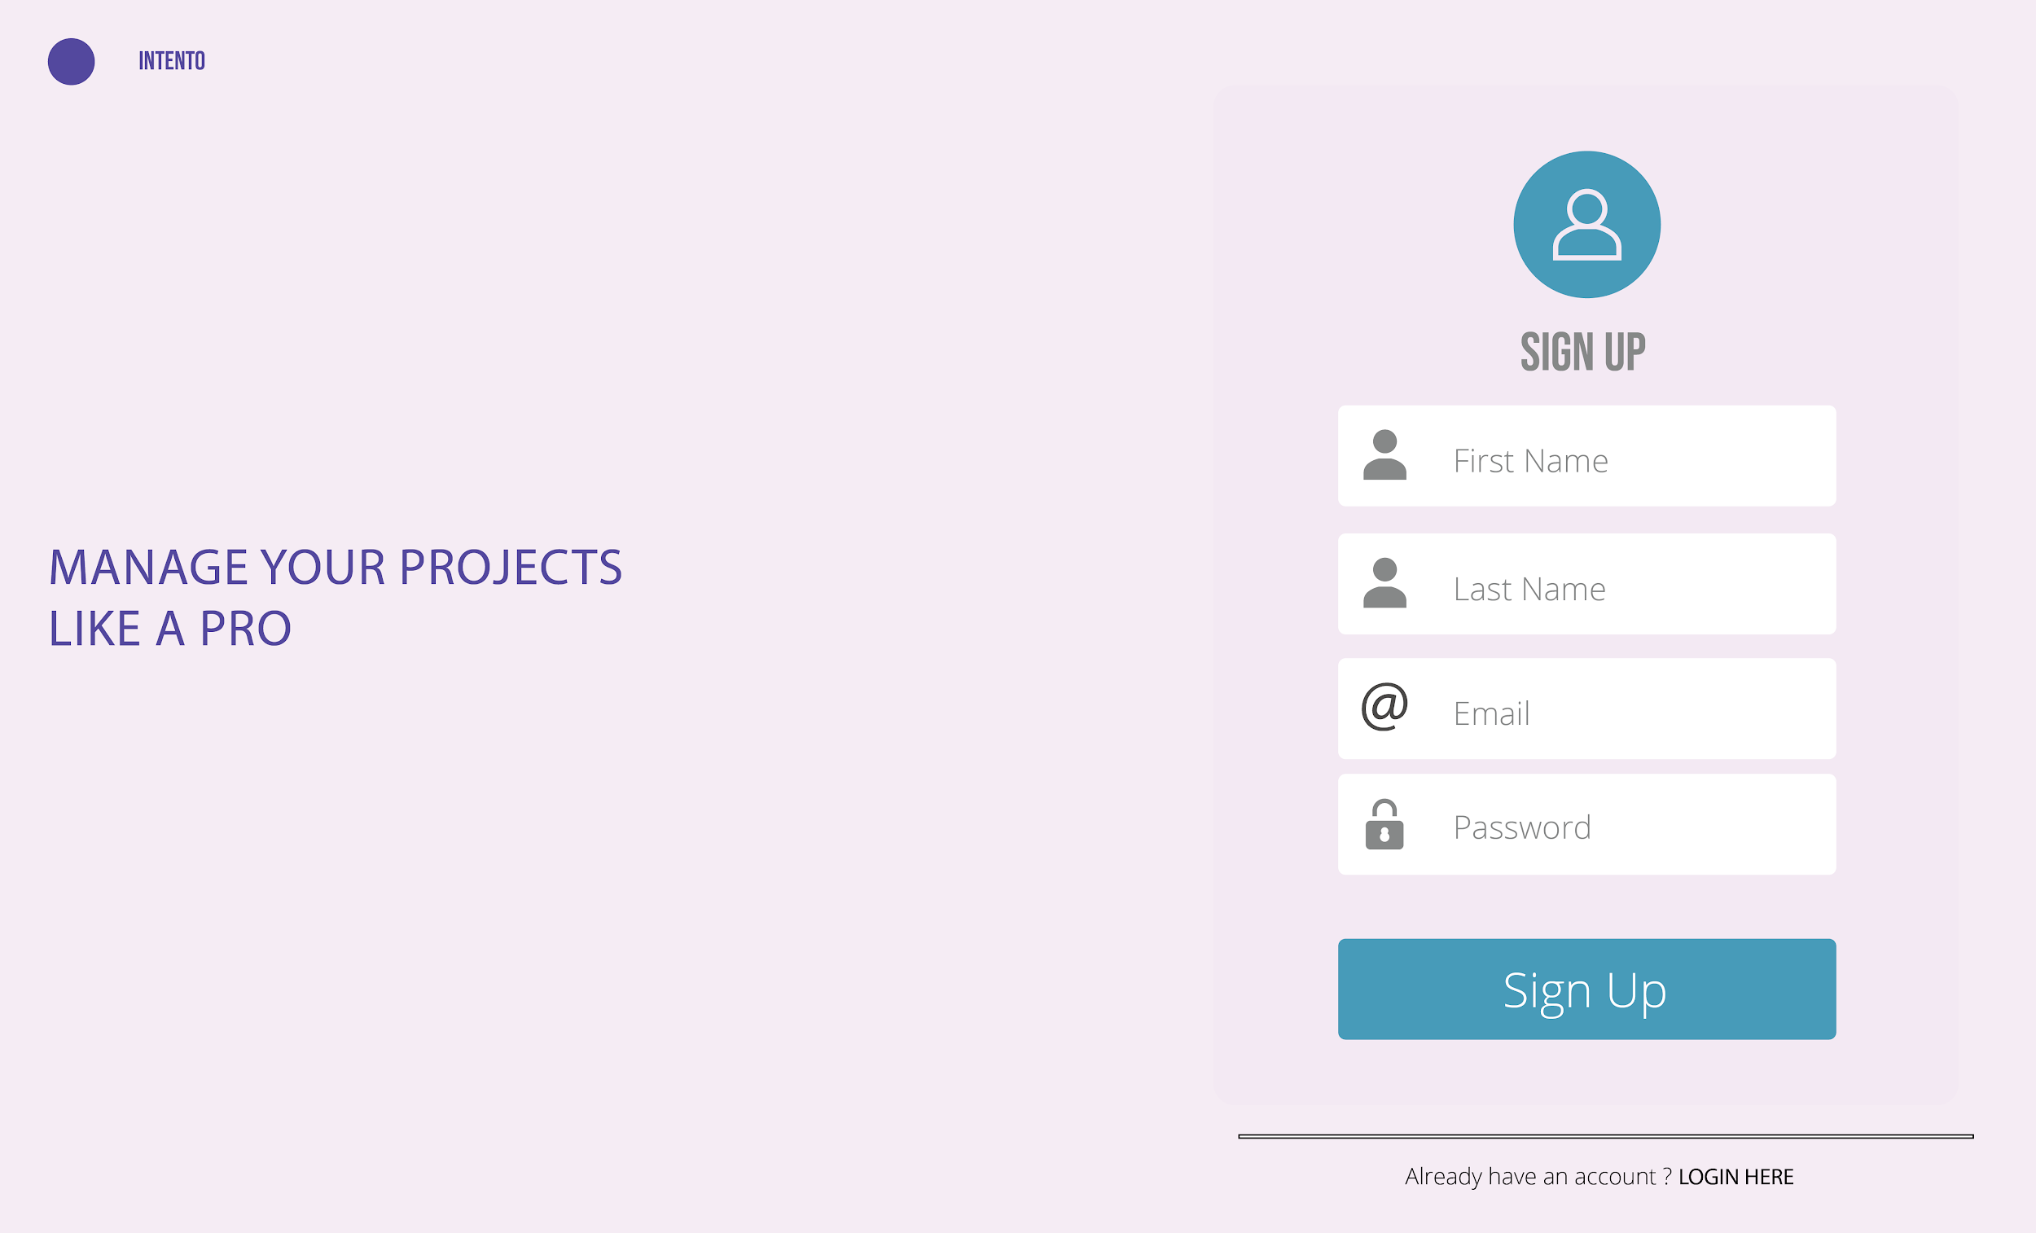

/projects

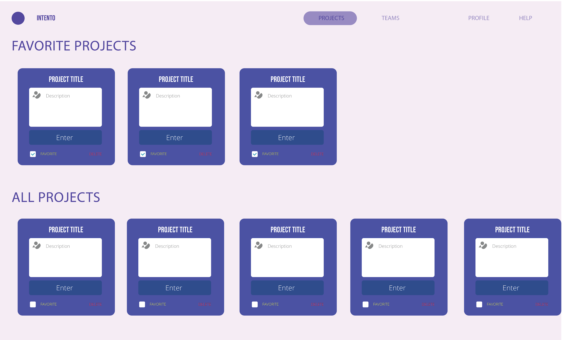

/teams

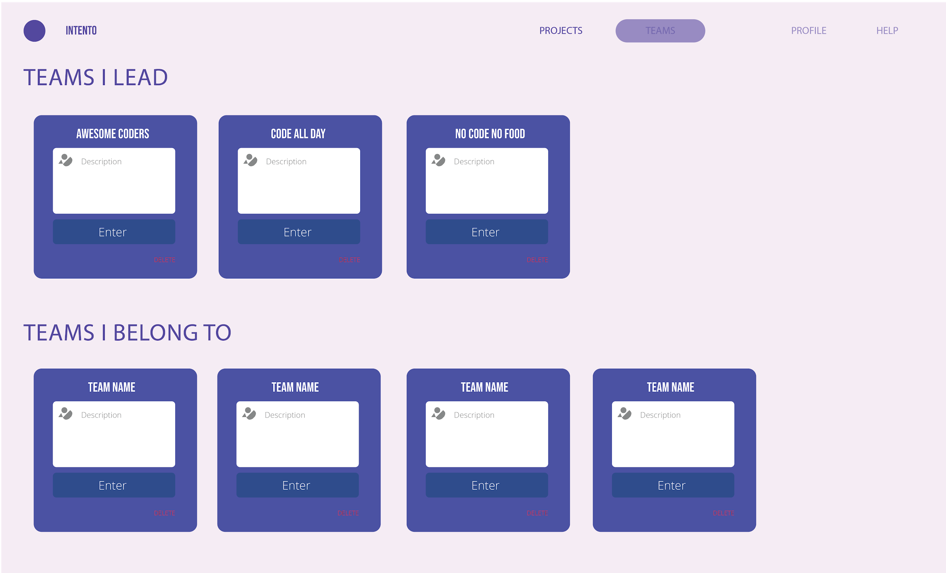

/project/id

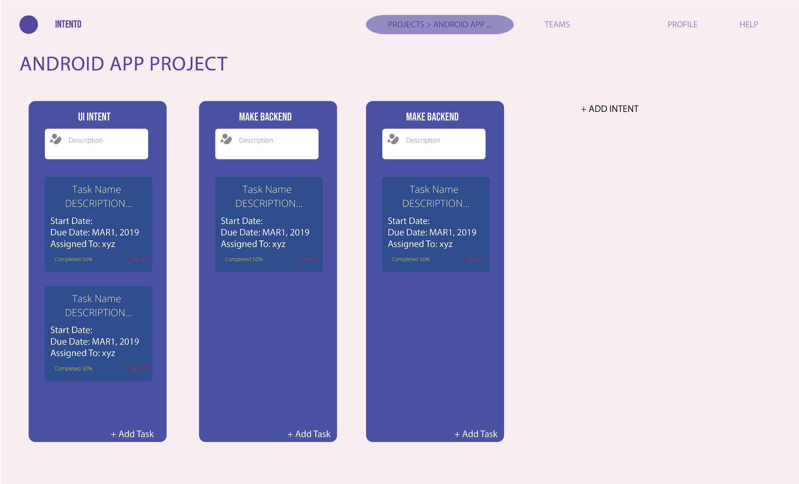

/profile/id

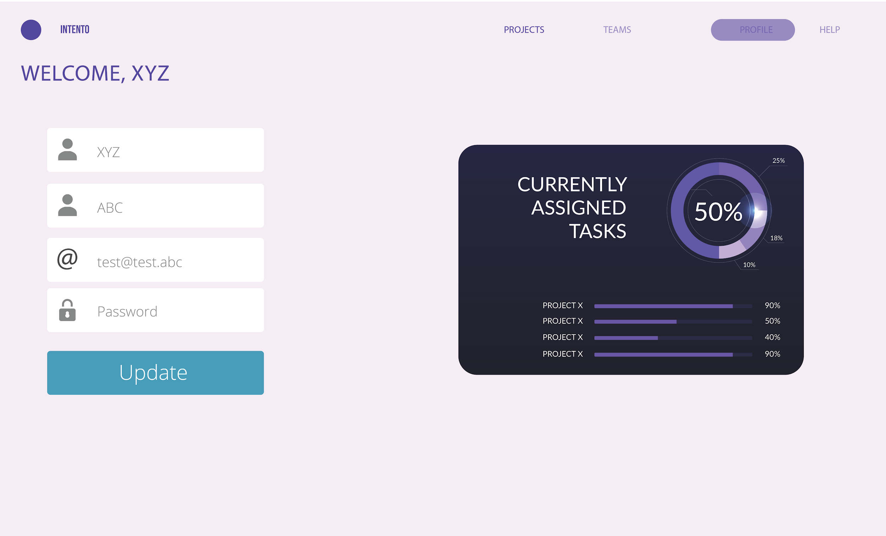

# Database Schema

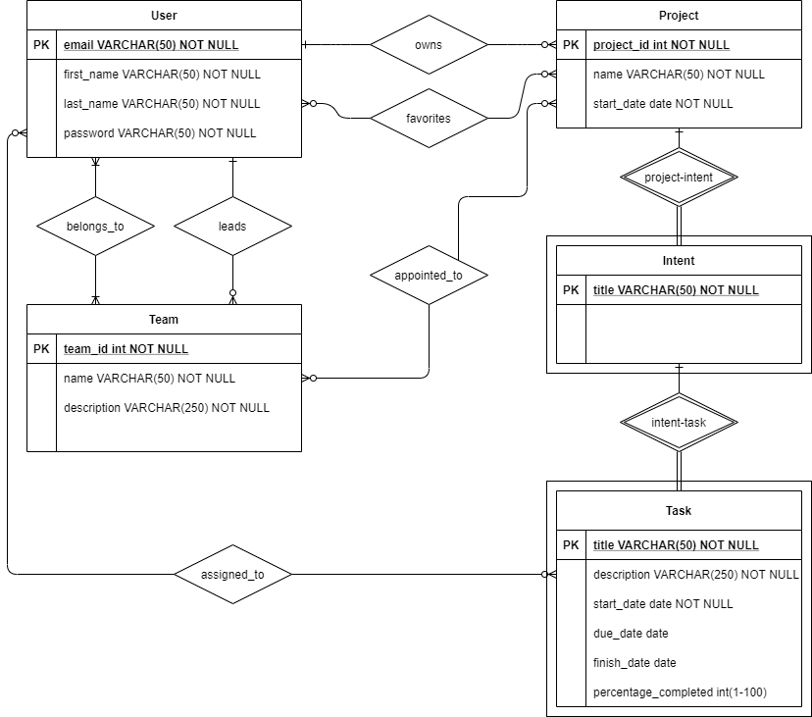

# Relational Database

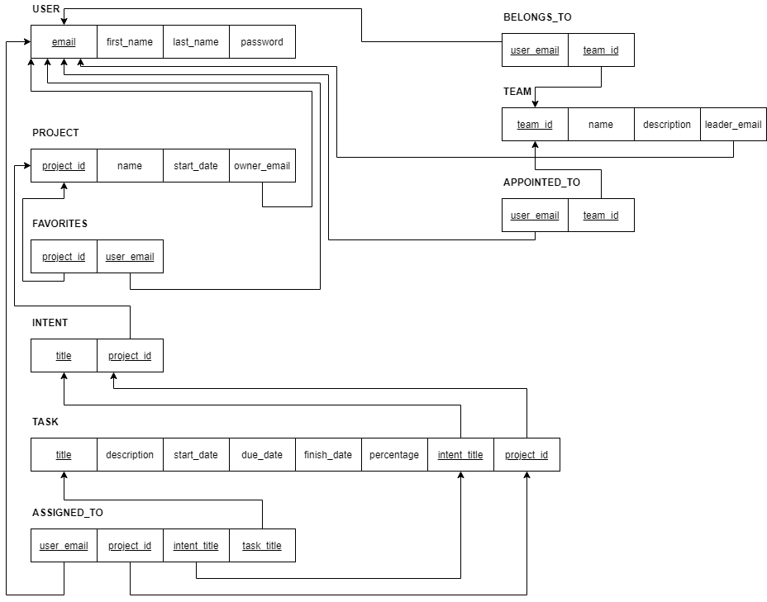

# Project Timeline

|  |  |
| --- | --- |
| **Day - Week** | **Progress Plan** |
| 8 August | Project Proposal |
| 22 August | Profile page and teams |
| 29 August | Project page & UI improvements |
| 5 September | Intents and Tasks |
| 12 September | Testing and optimizations |
| 19 September | Deployment to a free hosting server |

# Future Plans

* Refactor code and port to a robust framework
* Add real-time collaboration to tasks
* Make the website more dynamic with real-time changes
* Add email notification system
* Connect Projects with Git Repository providers (E.g. Github)